THE EARLY HISTORY OF WILTON CASTLE, BREE, CO. WEXFORD
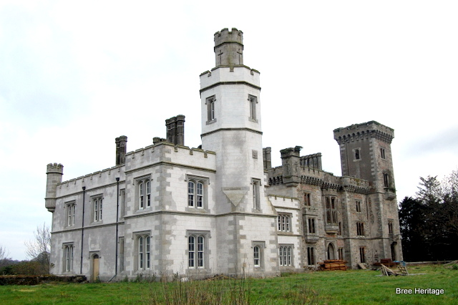
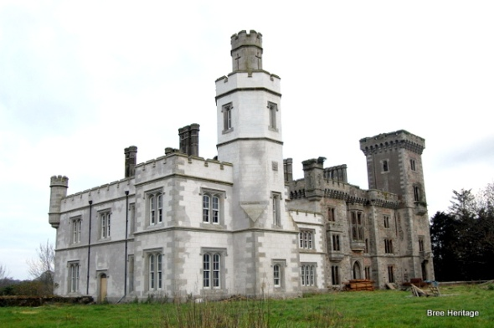Wilton castle
Wilton Castle has long and varied history and it is associated with some of County Wexford’s most esteemed families including the De Denes, Furlongs, Butlers and Alcocks (location map). In its earliest days it was the centre of a large medieval manor that was referred to as Kayer. This manor or barony covered much of the modern parishes of Bree, Davidstown and Glynn and was referred to variously as Kayer, Keir, Kyre, and Caher.
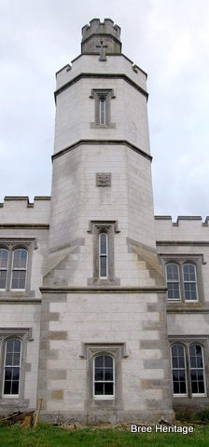
In 1247 William de Dene is recorded as baron of Keyer (Wilton), although it is likely that the Dene’s were in possession of these lands since at least the early 13th century[i]. Their initial caput (base) may have been at Dunanore, Bree, where a large ring-work castle overlooks the River Boro (more on Dunanore here). This highly defensible but difficult-to-reach site may have been abandoned in favour of Wilton as William’s estate at Kayer became more secure.
William, himself, was an important member of the nascent Anglo-Norman aristocracy, owning extensive lands in Wexford, Kilkenny and Carlow. He held the position of Sheriff of Wexford between 1241 and 1245 when he witnessed three of William Marshall’s charters at Dunbrody[ii]. In 1255 he was made seneschal of Ossory (Kilkenny), while in 1260/61 he achieved the prestigious position of Chief Justicar (the King of England’s chief minister in Ireland)[iii]. In 1261 he was involved in the in the Battle of Callan, Co. Kerry where the Anglo-Normans suffered a disastrous defeat to Finghin McCarthy, King of Desmond. William died shortly afterwards possibly from wounds suffered during this encounter.
He was succeeded by three of his sons, William, Walter (†1273) and Thomas (†1275) all of whom died within a few years of each other[iv]. His fourth son Reginald then inherited the estate and he held the title of ‘Baron of Keir’ until his death in 1302. In addition to his Wexford lands this powerful magnate also possessed estates in Cork, Waterford, Kilkenny and Carlow.
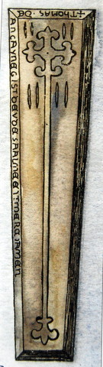Bishop Thomas de Denne’s gravestone

Thomas De Denne, bishop of Ferns was also reputedly born at Kayer and he may have been a great-grandson of Reginald. Although Thomas had powers to administer both civil and martial law in the county, the threat from the resurgent Irish was such that he had to leave the episcopal seat of Ferns in the late 14th century. He fled south to the relative safety of Fethard-on-Sea where he erected a castle in 1375 [v]. (There are unusual structural features seen in Fethard castle which may be replicated at Wilton castle). On his death in 1400 Thomas was buried in Fethard where his elaborate gravestone can still be seen.
In 1374 Kayer briefly fell out of De Dene’s hands when Faulk Furlong inherited the estate on the death of his mother Ismay Dene[vi]. The first surviving reference to the castle of ‘Keyr’ also dates to 1374, when Stephen Furlong is described as its custodian for the duration of Fulk’s minority[vii]. The castle and lands were then worth 100s annually. The Furlongs lost control of the estate, however, before the end of the 15th century when it was once more recorded in De Dene hands.
The death of Sir Faulk Dene, Baron of Kayer is recorded in 1497[viii] and in the early 16th century his son Peter sold Kayer to Sir Richard Butler[ix]. The exact date of this transfer of lands remains uncertain, although it may have occurred sometime around 1537 when Thomas Cromwell granted lands in ‘Fassagh Bentre’ (wilderness/waste of Bantry) to Sir Richard Butler[x]. Fassagh Bantry was another name for an area of west and central Wexford that was deemed particularly lawless, hence its ‘wild’ epithet. The Manor of Kayer occupied a large portion of this district and this grant probably refers to the estate at Wilton.
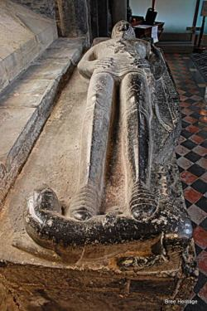Richard Butler’s elaborate tomb in St. Canice’s Cathedral

In February of 1537 a suggestion had been made that ‘Fassagh Bentre and Old Rosse’ (along with other areas) should be secured by giving it to a ‘gentlemen of Ireland, a younger brethren of good discretion’[xi]. Richard Butler, who was the younger brother of the Earl of Ormonde, fitted this description perfectly. To secure these new possessions he was expected to ‘keep soldiers in wages for two or three years’ and then allot them lands in freehold (for free). By populating Fassagh Bantry/Kayer with loyal soldiers it was hoped that the area would become more secure. The ‘common people’ (Irish) would be allowed to remain, ‘as there are no better earth tillers, or more obedient if kept from war’[xii]. However, things didn’t go as the government planned.
Just three years later in 1540 Sir William Saint Loo, the Sheriff of Wexford, complained that Richard was allowing too many Irish tenants on his estate in the ‘fasaghe of bentre’ under the pretence that they ‘manured’ his land. Furthermore the ‘Kavanaghes’ were passing unmolested through his lands to ‘spoil’ the southern parts of Wexford[xiii]. Similarly in 1548, Anthony Colclough complained that Richard was sheltering Irish thieves at ‘Cayre’ and furthermore that he was ‘an evil example to all men, making preys, in wounding men at night and taking gentle women prisoners’[xiv].
These complaints, however, were to fall on deaf ears, probably because, as already mentioned, Richard was the brother of one of Ireland’s most powerful men, the Earl of Ormonde. Indeed, Richard was an eminent man in his own right, owning extensive lands in both Kilkenny and Wexford. In 1550 he was created Viscount Mountgarret by King Edward VI and that same year he was also made constable of Ferns castle[xv]. From here he was expected to defend the northern part of the county from attacks by the O’Byrne and Kavanagh clans.
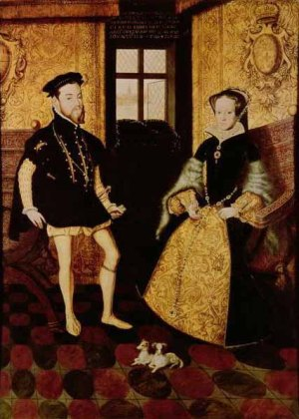The marriage of Philip II of Spain and Mary I of England
Four years later he had a much greater prize to defend, when he rallied to protect the Catholic Queen of England, Mary I. He travelled to England and was commended for his defence of London against a rebellious Protestant army led by Thomas Wyatt[xvi]. Richard appears to have been a trusted ally of the Queen and in March 1554 he was sent to Spain to help arrange her marriage to Phillip II[xvii]. He was richly rewarded for this work, receiving a gold chain worth £200 from the Spanish king[xviii]. The two monarchs married later that year and for a brief period Spain and England were allies.
In 1558 Richard was back in Wexford leading a commission of martial law with Sir Nicholas Devereux in the territories of ‘Fassaghbentry and LeMoroe’s country’[xix] (the latter roughly equating to north county Wexford). The following year he was again on expedition carrying out military duties in Kilkenny, Wexford and Tipperary, while in 1564 he was made Seneschal of Wexford.
Richard passed away in 1571 and was buried at St. Canice’s cathedral Kilkenny city where his magnificent tombstone can still be seen (see image below). His first son Edward inherited the title Viscount Mountgarrett and his lands in Kilkenny and around New Ross, while his second son Pierce took over the Manor of Kayer. Indeed, it seems that Pierce may have held Kayer, on behalf of his father since 1553, when he recorded as being at ‘Caher’[xx].
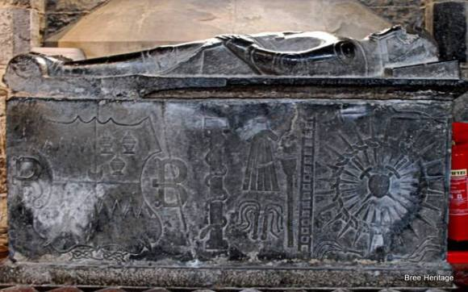Richard Butler’s tomb
Pierce’s temperament was apparently questionable as in 1574 he was described as a ‘rash young man’[xxi]. Another document from 1585 suggests that Pierce also had close ties with his Gaelic neighbours. It describes how ‘Peter Butler of Caher’ and a number of other men put forward a surety of £240 to guarantee that Morgan Cavanagh, an Irish rebel, would maintain the peace[xxii]. Pierce went onto marry Margaret Devereux, who was a daughter of his father’s ally Sir Nicholas Devereux of Ballymagir and on his death in 1598 his remains were interred at St, Mary’s church New Ross. His lands at Kayer were inherited by his eldest son Edward, who was then aged 22[xxiii].
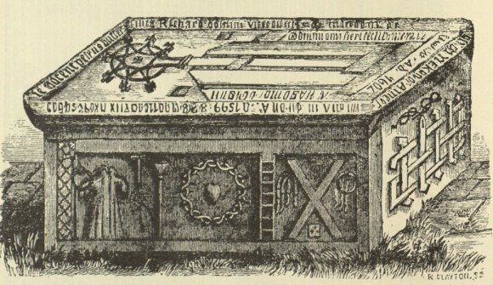Pierce Butler’s tomb in St. Mary’s, New Ross
The following year (1599) Edward built a new house at ‘Caher’[xxiv] and some of this building may survive imbedded in the present day ruins of Wilton castle. The remainder of Edward’s estate can be discerned from an Inquisition carried out in 1618[xxv]. This describes his possessions as including the castle and town of ‘Cayer’, otherwise known as ‘Cloghnekeraghe’, along with extensive lands which encompassed much of the present day parishes of Bree, Davidstown and Glynn. When Edward died in 1628 his large estate passed onto his son Pierce Butler.
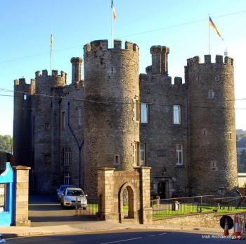Enniscorthy Castle
Pierce was deeply involved in the Wars of the 1640’s being a Colonel in the Confederate army and also a member of the Council of Kilkenny[xxvi]. In 1641 he led an attack on Enniscorthy, capturing the town’s castle and evicting many of the town’s Protestant population. He is recorded as carrying out numerous raids including the capture and burning St. John’s castle, just outside Enniscorthy. He also helped besiege Tintern castle/abbey and was involved in the protracted siege of Duncannon fort.
However, the arrival of Cromwell in 1649 was to see the war turn against the Confederates and Pierce Butler lost all his lands in the subsequent Cromwellian confiscations. The extent of this estate can be seen in the Civil Survey of 1654 (but which recorded land ownership in 1640-41)[xxvii]. It describes Pierce’s property as containing over 7,000 acres of land as well as a ‘fayre castle, diverse houses and offices, a good water mill and a coneyborough’ (rabbit warren).
This extensive estate was subsequently granted to Captain Robert Thornhill, who had been an officer in Cromwell’s army[xxviii]. However, nearly a decade of war had left the lands in some disrepair and in 1659 Thornhill complained that wolves were causing havoc in the district[xxix]. This and other factors appears to have left the Thornhill’s less than enamoured with Kayer and 1695 they sold the estate to William Alcock[xxx].
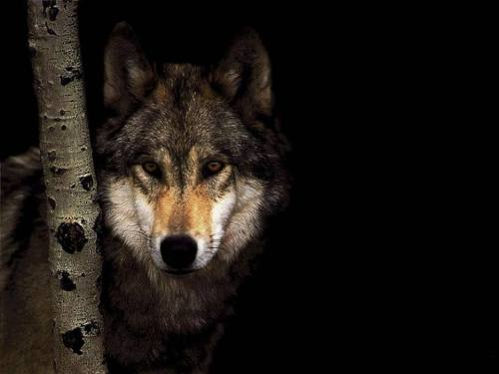Wolf
William Alcock set about improving the property and renamed the estate Wilton and also built a new mansion to replace Edward Butler’s ‘house’. This mansion was built according to the then fashionable ‘William and Mary’ style of architecture[xxxi]. A large and impressive late 17th century/early 18th century doorway which was later reused in the stable yard may belong to this mansion (see image on the right). The next major refurbishment work carried out at Wilton castle occurred between 1836 and 1838, when Harry Alcock commissioned Daniel Robertson to redesign the house. This work was very extensive and most of the present day ruins date from this period of remodelling. The house was unfortunately burnt down in 1923 (see below).
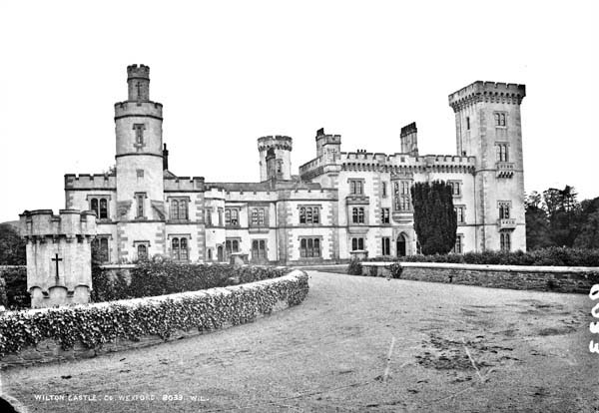Wilton castle before the fire (source National Library of Ireland)
A description of the burning of Wilton Castle from the Irish Times, 7th of March 1923[xxxii]
Enniscorthy Mansion Burned: Roofless Walls And Smoking Ruins: Work Of Armed Raiders.
The arsonists’ target in this instance was Wilton Castle, the impressive house designed by Daniel Robertson (d. 1849) for Harry Alcock (1792-1840) enveloping an ‘old mansion which was in the dull style of the period of William and Mary’ (Doyle 1868, 179) (figs. 10-11). As outlined in the report: ‘Wilton Castle, the residence of Captain P.C. Alcock, about three miles from Enniscorthy, was burned by armed men on Monday night. Nothing remains of the beautiful building but smoke-begrimed, roofless walls, broken windows, and a heap of smouldering debris. The Castle was occupied by a caretaker – Mr. James Stynes – the owner, with his wife and family, having gone to England about a year ago. Shortly after 9 o’clock on Monday night the caretaker was at the Steward’s residence…when he was approached by armed men, who demanded the keys to the Castle. When he asked why they wanted the keys, one of the armed men said: “We have come to burn the place. We are sorry”. The raiders told the caretaker that he could remove his personal belongings from the part of the Castle that he occupied, but they would not allow him to remove the furniture. Fearing that the Castle might be burned, however, Captain Alcock had removed the most valuable portion of his furniture some weeks ago, but a good many rooms were left furnished. When the caretaker had removed his property he was ordered back to the Steward’s house. Soon the noise of breaking glass was heard. It appears that the armed men broke all the windows on the ground floor, and having sprinkled the floors with petrol, set them alight. They did not hurry over their work of destruction, and they did not leave the Castle until near 12 o’clock, when the building was enveloped in flames. About thirty men took part in the raid. After the raiders left, the caretaker and Steward, with what help they could procure, tried to extinguish the flames, but their effort was hopeless’.
Endnotes
[i] St. John Brooks, E. 1950. Knights’ fees in counties Wexford, Carlow and Kilkenny. Dublin, p. 49
[ii] Ibid, p. 49
[iii] Ibid, p. 49
[iv] Ibid, p.50
[v] Colfer,B. 2004. The Hook Peninsula. Cork. p.79.
[vi] Circle: A Calendar of Chancery Letters 1244-1509; Patent Roll 48 Edward III. URL: http://chancery.tcd.ie/document/patent/48-edward-iii/10?view=chancery_advanced_search&display=search_persons_or_page&path=search-persons-text&surnametext=Furlong&surname=Furlong&forename=Furlong&titlestatus=Furlong&office=FurlongDate Accessed 23 April 2012

THE GHOSTS OF WILTON CASTLE, WEXFORD
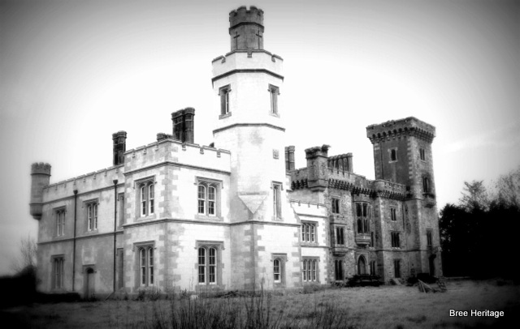
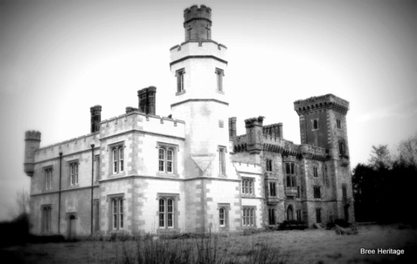
On the eve of Halloween it seems only fitting that we discuss the ghosts and spectres that are said to haunt the ruins of Wilton Castle. Wilton or Kayer, as it was formerly known, was first built by the De Dene familly, probably in the early 13th century. Over the proceeding years it was also to be the residence of the Furlong and Butler families before finally becoming the home of the Alcocks in the late 17th century. It was the Alcock family who constructed the now familar Neo-Gothic mansion, the ruined remains of which, still tower above the adjacent River Boro (the castle was burnt down during the troubles).
If the local legends are to be believed, a fair number of ghosts now lurk within the castle’s walls. One story recounts strange lights that are sometimes seen in the ruins of a castle tower where an old woman died in a fire. Another tale states that every year on the anniversary of his death, the shadow of Harry Alcock, who died in 1840, is seen driving slowly away from the castle in a ghostly carriage. Crowds once gathered in anticipation of the event, and a local shoemaker claimed to have spoken with the phantom.
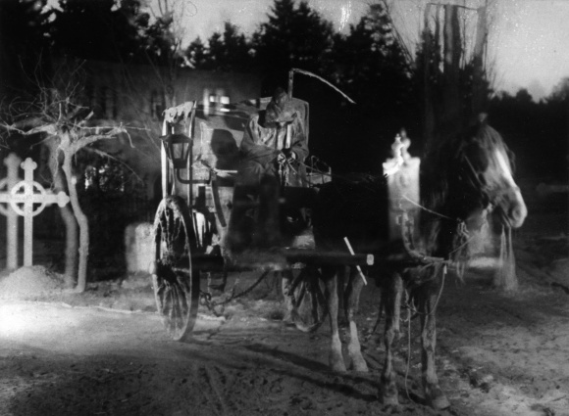
The strangest tale, however, is that of Archibald Jacob, who served as a local magistrate and also captained a loyalist militia company during the rebellion of 1798. Jacob had a notorious reputation and is thought to have flogged and tortured many people in the parish. While returning home one night from a ball at the castle he fell from his horse while crossing a stream and was killed. For years afterwards his ghost was said to haunt both the scene of his death and the castle. On one occasion, a Catholic priest was summoned to the castle to conduct an exorcism. When he made the sign of the cross, the ghost of Archibald Jacob allegedly appeared in the fireplace, then disappeared in a cloud of smoke.
GHOSTS WILTON CASTLE WILTON WEXFORD
- TWITTER
- FACEBOOK

